Prediction of Bike Rental Count daily based on environmental and seasonal settings

Abinash Pradhan

Contents
1. | Introduction |  |  |  | 1
 | 1.1 Problem Statement . . . . . . . . . . . . . . . . |  | . . . . . . . . . . . . . . . . . . . . . . . . . . . . . . . |  | 3
 | 1.2 Data . . | . . . . . . . . . . . . . . . . . . . . . . . . . . . | . . . . . . . . . . . . . . . . . . . . . . . . . . . . . . . |  | 3
2. | Methodology |  |  |  | 4
 | 2.1 Data Pre-Processing . . . . . . . . . . |  | . . . . . . . . . . . . . . . . . . . . . . . . . . . . . . |  | 4
 | 2.1.1 Distribution of Categorical Variables . . . . . . . . . . . . . . . . . . . . . . . . . . . |  |  |  | 5
 | 2.1.2 | Distribution of Continuous Variables . . . . . . . . . . . . . . . . . . . . . . . . . . |  |  | 5
 | 2.1.3 Relationship between Continuous Variables and Bike Count . . . . . . . . |  |  |  | 8
 | 2.1.4 | Missing Value analysis . . . . . . . | . . . . . . . . . . . . . . . . . . . . . . . . . . . . . . . . |  | 12
 | 2.1.5 | Outlier Analysis . . . . . . . . . . . . . | . . . . . . . . . . . . . . . . . . . . . . . . . . . . . . . |  | 13
 | 2.1.6 | Feature Selection . . . . . . . . . . . . | . . . . . . . . . . . . . . . . . . . . . . . . . . . . . . . |  | 14
 | 2.2 Modelling . . . . . . . . . . . . . . . . . . |  | . . . . . . . . . . . . . . . . . . . . . . . . . . . . . . . |  | 17
 | 2.2.1 | Model Selection . . . . . . . . . . . . . | . . . . . . . . . . . . . . . . . . . . . . . . . . . . . . . |  | 17
 | 2.2.2 | Decision Tree . . . . . . . . . . . . . . . | . . . . . . . . . . . . . . . . . . . . . . . . . . . . . . . . |  | 17
 | 2.2.3 | Multiple Linear Regression . . . . | . . . . . . . . . . . . . . . . . . . . . . . . . . . . . . . . |  | 18
 | 2.2.4 | Random Forest . . . . . . . . . . . . . | . . . . . . . . . . . . . . . . . . . . . . . . . . . . . . . . |  | 20
3. Conclusion |  |  |  | 21
3.1 Model Evaluation . . . . . . . . . . . . . . . . . . . . . . . . . . . . . . . . . . . . . . . . . . . . . 21
3.1.1 RMSE and R-Squared . . . . . . . . . . . . . . . . . . . . . . . . . . . . . . . . . . . . . . . . . . 21
3.2 Model Selection . . . . . . . . . . . . . . . . . . . . . . . . . . . . . . . . . . . . . . . . . . . . . . 21
Python - Code . . . . . . . . . . . . . . . . . . . . . . . . . . . . . . . . . . . . . . . . . . . . . . . . . . . . . . . .22
R - Code . . . . . . . . . . . . . . . . . . . . . . . . . . . . . . . . . . . . . . . . . . . . . . . . . . . . . . . . . . . . . 42

Chapter 1: Introduction

1.1 Problem Statement
The Objective of this problem is to Predict number of bike rental count daily based on the environmental and seasonal settings, and by predicting the count it will be easy to manage the number bikes required on the daily basis and preparing the bike demand based on Environmental Changes.
1.2 Data
Our task is to build Regression model which will predict the bike rental count daily based on the environmental and seasonal settings. Given below is a sample of the data set that we are using to predict the bike Rental count:
The details of data attributes in the dataset are as follows –
instant: Record index
dteday: Date
season: Season (1:springer, 2:summer, 3:fall, 4:winter)
yr: Year (0: 2011, 1:2012)
mnth: Month (1 to 12)
hr: Hour (0 to 23)
holiday: whether day is holiday or not (extracted from Holiday Schedule)
weekday: Day of the week
workingday: If day is neither weekend nor holiday is 1, otherwise is 0.
weathersit: (extracted from Freemeteo)
1: Clear, Few clouds, Partly cloudy, Partly cloudy
2: Mist + Cloudy, Mist + Broken clouds, Mist + Few clouds, Mist
3: Light Snow, Light Rain + Thunderstorm + Scattered clouds, Light Rain + Scattered
clouds
4: Heavy Rain + Ice Pallets + Thunderstorm + Mist, Snow + Fog
temp: Normalized temperature in Celsius. The values are derived via (t-t_min)/(t_max-t_min),
t_min=-8, t_max=+39 (only in hourly scale)
atemp: Normalized feeling temperature in Celsius. The values are derived via
(t-t_min)/(t_maxt_min), t_min=-16, t_max=+50 (only in hourly scale)
hum: Normalized humidity. The values are divided to 100 (max)
windspeed: Normalized wind speed. The values are divided to 67 (max)
casual: count of casual users
registered: count of registered users
cnt: count of total rental bikes including both casual and registered

As we can see in the table below, we have the following 13 variables, using which we have to correctly predict the bike rental count:
 | Table 1.3: Predictor variables
Sl.No |  | Variables
1 |  | Instant
2 |  | Dteday
3 |  | Season
4 |  | Yr
5 |  | Month
6 |  | Holiday
7 |  | Weekday
8 |  | Workingday
9 |  | Weathersit
10 |  | Temp
11 |  | Atemp
12 |  | Hum
13 |  | Windspeed

Chapter 2: Methodology

2.1 Data Pre-Processing
Any predictive modelling requires that we look at the data before we start modelling. However, looking at data refers to exploring the data, cleaning the data as well as visualizing the data through graphs and plots. This is often called as Exploratory Data Analysis. To start this process, we will first try and look at all the distributions of the variables. Most analysis like regression, require the data to be normally distributed. We can visualize that in a glance by looking at the probability distributions or probability density functions of the variable.

2.1.1 Distribution of Categorical Variables
The below bar graph shows the Distribution of Categorical variables in the dataset.
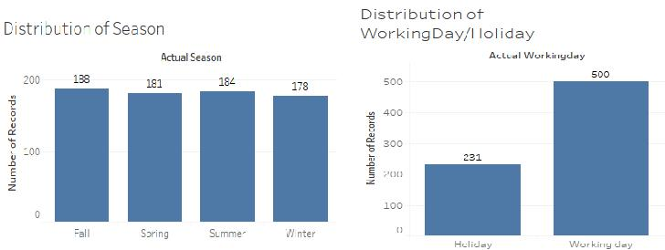

Fig 2.1: Distribution of categorical variables using bar graphs

2.1.2 Distribution of Continuous Variables
From the below distributions it can be observed that temperature and feel temperature are normally distributed, whereas the variables windspeed and humidity are slightly skewed. The skewness is likely because of the presence of outliers and extreme data in these variables.
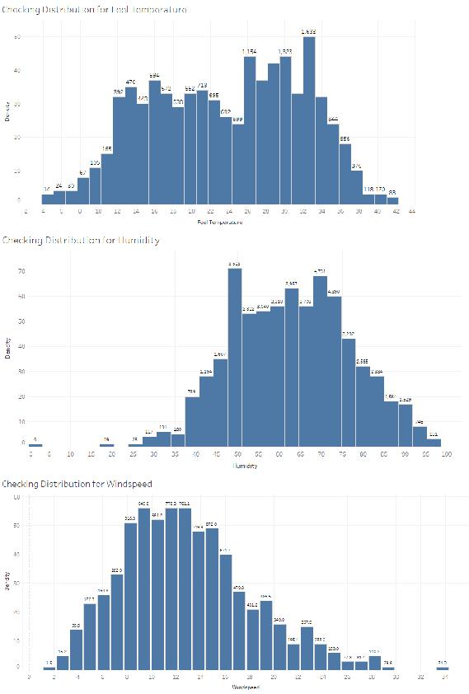
Fig 2.2: Distribution of continuous variables using histograms
2.1.3 Relationship of Continuous Variable with target Variable
The below figure shows the relationship between the continuous variables against target variable (bike count) using Scatter plot. From the figure we can see how the data is scattered in temperature and feel temperature (atemp), and there exists a linear positive relationship between the variables, temperature and feel temperature against the target variable, and also linear negative relationship between humidity and windspeed with the target variable.
Scatter plot for Temperature
Scatter plot for Feel Temperature
Scatter plot for Humidity

Scatter plot for Wind speed

Fig 2.3: Scatter plot for continuous variables.

Fig 2.4: Relationship between the variables against bike count

From the above figures we can observe how the bike rental count varies across the different seasons and in that fall season have more bike rental count, the temperature also varies across the season and its mean also changes in all seasons, when it comes to working day and holiday there are more number of bike rental count when the day is working day.

2.1.4 Missing Value Analysis
Missing data or missing values occur when no data value is stored for the variable in an observation. Missing values are a common occurrence in data analysis. These values can have a significant impact on the results or conclusions that would be drawn from these data. If a variable has more than 30% of its values missing, then those values can be ignored, or the column itself is ignored. In our case, there is no missing values occurred in the dataset.
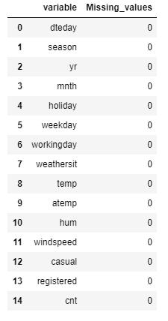
Fig 2.5: Missing value analysis

2.1.5 Outlier Analysis
It can be observed from the distribution of variables that almost all of the variables are normally distributed. The skew in these distributions can be explained by the presence of outliers and extreme values in the data. One of the steps in pre-processing involves the detection and removal of outliers. We will use Boxplot to visualize and remove outliers.
Outliers can be removed using the Boxplot stats method, wherein the Inter Quartile Range (IQR) is calculated and the minimum and maximum value are calculated for the variables. Any value ranging outside the minimum and maximum value are discarded.

Variables windspeed and humidity contain outliers, the below figure shows the boxplot representation of the variables with outliers.

Fig 2.6: Boxplot of continuous variables with outliers
The below figure shows the boxplot representation of the variables without outliers.
Fig 2.7: Boxplot of continuous variables without outliers

2.1.6 Feature Selection
Feature Selection reduces the complexity of a model and makes it easier to interpret. It also reduces overfitting. Features are selected based on their scores in various statistical tests for their correlation with the outcome variable. Correlation plot is used to find out if there is any multicollinearity between variables. The highly collinear variables are dropped and then the model is developed and executed.
From correlation analysis we have found that Temperature and atemp are highly correlated with each other (>=0.9), so we have excluded atemp, and workingday variable (carrying holiday information) so excluded holiday variable and also casual, registered are not required.
Fig 2.9: Correlation plot of Continuous variables

Let us analyze for categorical variables:
We will not use instant and dteday column, as instant is index only and information of dteday i.e. yr, month and day we have already columns for that. Dteday is important factor while doing time series analysis and we are not doing time series analysis.
For getting dependency between categorical variables we will use chi-square test of independence test. Basically we have mnth, yr, weekday, holiday, workingday, weathersit and season as categorical variables. We will use all the variables to check their dependency.

Null Hypothesis for Chi-square test of Independence:
Two variables are independent.
Alternate Hypothesis:
Two variables are not independent.
So, we want that our categorical variables should be independent. If we get p-value less than 0.05, it means we need to reject null hypothesis and accept alternate hypothesis which means variables are dependent. So, we would check for every combination and print p-value.
Analysis:
Here, from the table we can see some values are less than 0.05 indicating that they are dependent, holiday is showing collinearity with weekday and workingday, month is showing collinearity with season and weathersit, weathersit showing collinearity with season.
Now, we need to drop them to remove multicollinearity. But we have to be sure that we are not losing any information. So, we tried with dropping multicollinear column and building models and we got below result:
- On dropping weathersit or season we are losing accuracy with significant amount.
- On dropping holiday we are losing accuracy which is not significant amount.
- On dropping weekday or working day we are losing accuracy with little amount. And if we drop holiday, that information is also included in working day.
We just can’t be sure by looking at test result and deciding, we need to get all factors. Here two columns most of the time showing collinearity but some data points would not be showing collinearity and at that data point there could be abrupt difference in bike renting count column which is very important information for our model.
We will drop only holiday column as we have working day column which has information of holiday also, that is why on dropping holiday we are not losing our accuracy.
Let us analyse for continuous variables using VIF (Variance inflation Factor):
Checking VIF for continuous variables:
From above results atemp have multicollinearity with temp.
After removing atemp lets check again for VIF.
Now we have good value of VIF, don’t have multicollinearity.

2.2 Modelling
2.2.1 Model Selection
After a thorough pre-processing, we will be using regression models on our processed data to predict the target variable. The target variable in our model is a continuous variable i.e. cnt (Bike count). Hence the models that we choose are Linear Regression, Decision Tree and Random Forest. The error metrics chosen for the given problem statement is Root Mean Squared Error(RMSE) and R²(R-Squared).
2.2.2 Decision Tree
Decision Tree algorithm belongs to the family of supervised learning algorithms. Decision trees are used for both classification and regression problems. A decision tree is a tree where each node represents a feature (attribute), each link (branch) represents a decision (rule) and each leaf represents an outcome (categorical or continues value). The general motive of using Decision Tree is to create a training model which can predict class or value of target variables by learning decision rules inferred from prior data (training data).
The RMSE values and R2 values for the given project in R and Python are:
Decision Tree | RMSE | R2
R | 961 | 0.76
PYTHON | 962 | 0.73

Using decision tree in R, we can predict the value of bike count. RMSE and R2 for this model is 961 and 0.76, The MAPE for this decision tree is 17.75. Hence the accuracy for this model is 82.25%.

2.2.3 Multiple Linear Regression
Multiple linear regression is the most common form of linear regression analysis. Multiple linear regression is used to explain the relationship between one continuous dependent variable and two or more independent variables. The independent variables can be continuous or categorical.
Multiple Linear | RMSE | R2
Regression
R | 847 | 0.82
PYTHON | 872 | 0.78
As you can see the Adjusted R-squared value, we can explain 84.38% of the data using our multiple linear regression model. By looking at the F-statistic and combined p-value we can reject the null hypothesis that target variable does not depend on any of the predictor variables. This model explains the data very well and is considered to be good.
Even after removing the non-significant variables, the accuracy, Adjusted R-squared and F- statistic do not change by much, RMSE is calculated and found to be 847.82.
MAPE of this multiple linear regression model is 17.18. Hence the accuracy of this model is 82.82%. This model performs well for this test data.
2.2.4 Random Forest
Random Forest is a supervised learning algorithm. Random forest builds multiple decision trees and merges them together to get a more accurate and stable prediction. It can be used for both classification and regression problems. The method of combining trees is known as an ensemble method. Ensembling is nothing but a combination of weak learners (individual trees) to produce a strong learner.
The number of decision trees used for prediction in the forest is 500.
Random Forest | RMSE | R2
R | 693 | 0.88
PYTHON | 669 | 0.87
Using Random forest for prediction analysis in this case the number of decision trees used for prediction in the forest is 500. RMSE for this model is 669.
Using random forest, the MAPE was found to be 12.89, Hence the accuracy is 87.11%

Chapter 3: Conclusion
3.1 Model Evaluation
In the previous chapter we have seen the Root Mean Square Error (RMSE) and R-Squared Value of different models. Root Mean Square Error (RMSE) is the standard deviation of the residuals (prediction errors). Residuals are a measure of how far from the regression line data points are. RMSE is a measure of how spread out these residuals are. In other words, it tells you how concentrated the data is around the line of best fit. Whereas R-squared is a relative measure of fit, RMSE is an absolute measure of fit. As the square root of a variance, RMSE can be interpreted as the standard deviation of the unexplained variance and has the useful property of being in the same units as the response variable. Lower values of RMSE and higher value of R-Squared Value indicate better fit.
3.1.1 RMSE and R-Squared
Root Mean Square Error (RMSE) is the standard deviation of the residuals (prediction errors). Residuals are a measure of how far from the regression line data points are, RMSE is a measure of how spread out these residuals are. In other words, it tells you how concentrated the data is around the line of best fit. Root mean square error is commonly used in climatology, forecasting, and regression analysis to verify experimental results.
RMSE = √(Predicted values – Observed values )2
R-squared (R2) is a statistical measure that represents the proportion of the variance for a dependent variable that's explained by an independent variable or variables in a regression model. Whereas correlation explains the strength of the relationship between an independent and dependent variable, R-squared explains to what extent the variance of one variable explains the variance of the second variable. So, if the R2 of a model is 0.50, then approximately half of the observed variation can be explained by the model's inputs.
3.1.2 Model selection
Multiple Linear Regression: RMSE = 847, R2 = 0.82
Decision Tree: RMSE = 961, R2 = 0.76
Random Forest: RMSE = 693, R2 = 0.88
Based on the above error metrics, Random Forest is the better model for our analysis. Hence Random Forest is chosen as the model for prediction of bike rental count.
Python code:
In [1]:
import datetime
import numpy as np
import pandas as pd
import matplotlib.pyplot as plt
import seaborn as sns
from random import randrange, uniform

In [2]: df = pd.read_csv("Day.csv",index_col = 0)

In [3]: df.head(10)
Out[3]:
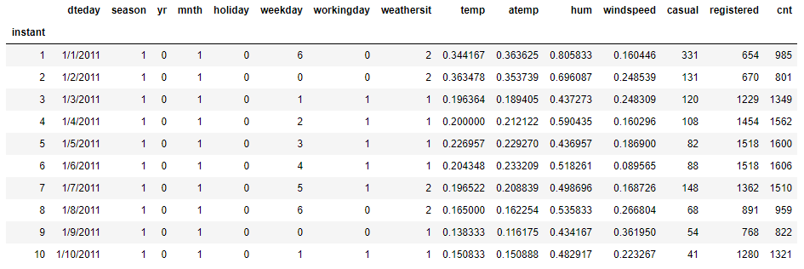

In [4]:
df.columns
Out[4]:
Index(['dteday', 'season', 'yr', 'mnth', 'holiday', 'weekday', 'workingday',
'weathersit', 'temp', 'atemp', 'hum', 'windspeed', 'casual', 'registered', 'cnt'],dtype='object')

Exploratory Data Analysis
In [5]: df.dtypes
Out[5]:
dteday object
season int64
yr int64
mnth int64
holiday int64
weekday int64
workingday int64
weathersit int64
temp float64
atemp float64
hum float64
windspeed float64
casual int64
registered int64
cnt int64
dtype: object

In [6]:
#Converting variables datatype to required datatypes
#Categorical variables
df['dteday'] = pd.to_datetime(df['dteday'],yearfirst = True)
df['season'] = df['season'].astype('category')
df['yr'] = df['yr'].astype('category')
df['mnth'] = df['mnth'].astype('category')
df['holiday']= df['holiday'].astype('category')
df['weekday']= df['weekday'].astype('category')
df['workingday']= df['workingday'].astype('category')
df['weathersit']= df['weathersit'].astype('category')

#Continuous variables
df['temp'] = df['temp'].astype('float')
df['atemp']= df['atemp'].astype('float')
df['hum'] = df['hum'].astype('float')
df['windspeed'] = df['windspeed'].astype('float')
df['casual'] = df['casual'].astype('float')
df['registered'] = df['registered'].astype('float')
df['cnt'] = df['cnt'].astype('float')

In [7]: df.dtypes
Out[7]:
dteday datetime64[ns]
season category
yr category
mnth category
holiday category
weekday category
workingday category
weathersit category
temp float64
atemp float64
hum float64
windspeed float64
casual float64
registered float64
cnt float64
dtype: object

In [8]: ordered_data = df.copy()

Missing Value Analysis

In [9]:
missing_val = pd.DataFrame(df.isnull().sum())
missing_val = missing_val.reset_index()
missing_val = missing_val.rename(columns={'index':'variable',0:'Missing_values'})
In [10]:
missing_val
Out[10]:
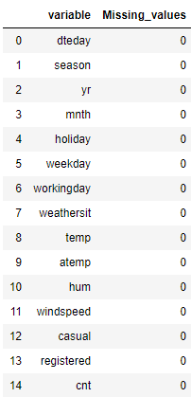

**Distribution of Data by Visualizations
In [11]:
#Creating new variables from existing variables for visualizations (Feature Engineering)
df['actual_temp'] = df['temp'] * 39
df['actual_atemp'] = df['atemp'] * 50
df['actual_windspeed'] = df['windspeed'] * 67
df['actual_hum'] = df['hum'] * 100
In [12]:
df.columns
Out[12]:
Index(['dteday', 'season', 'yr', 'mnth', 'holiday', 'weekday', 'workingday',
'weathersit', 'temp', 'atemp', 'hum', 'windspeed', 'casual',
'registered', 'cnt', 'actual_temp', 'actual_atemp', 'actual_windspeed', 'actual_hum'], dtype='object')

In [13]: df.head()
Out[13]:
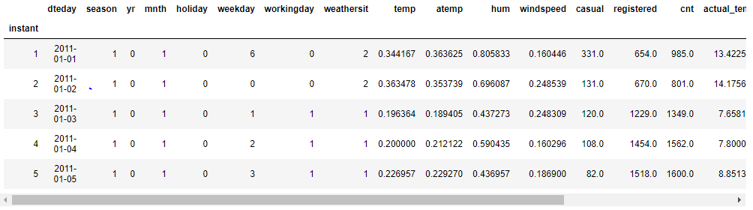

In [14]:
#Cheking the Distribution of data using Histograms
sns.set_style("whitegrid")
sns.distplot(df['actual_temp'],rug=True)
Out[14]
:
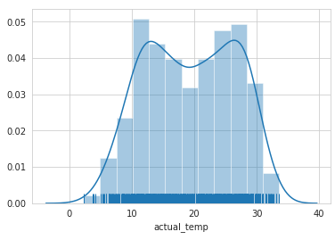

In [15]: sns.distplot(df['actual_atemp'], rug=True)
Out[15]:
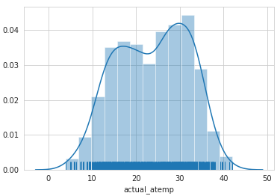
In [16]: sns.distplot(df['actual_hum'], rug=True)
Out[16]:
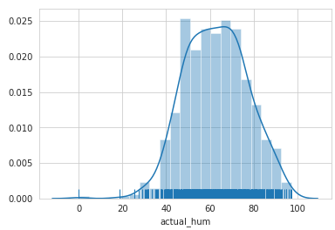

In [17]: sns.distplot(df['actual_windspeed'],rug=True)
Out[17]:
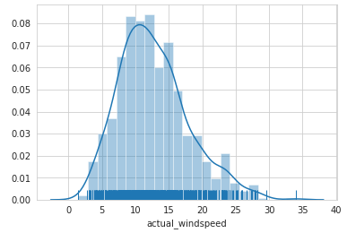

In [18]: sns.distplot(df['cnt'],rug=True)
Out[18]:
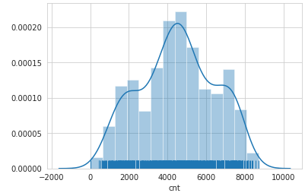

In [19]:
continuous_variables = ['actual_temp','actual_atemp','actual_windspeed','actual_hum','cnt']
for i in continuous_variables:
plt.hist(df[i],bins='auto')
plt.title("Checking Distribution for Variable "+str(i))
plt.ylabel("Density")
plt.xlabel(i)
plt.show()
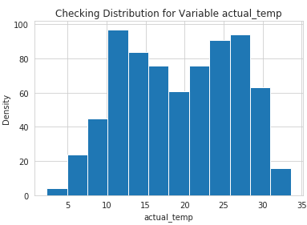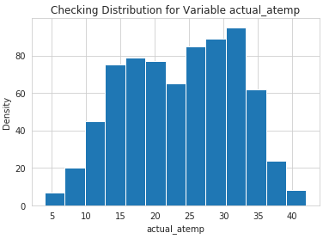

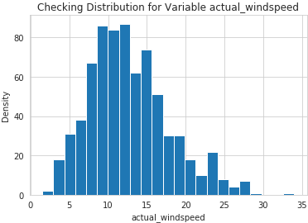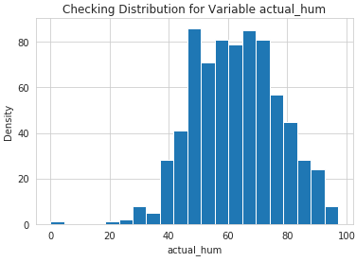

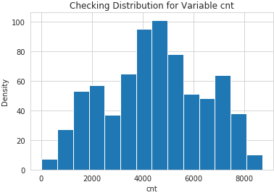

In [20]: #Bike Rentals Per Monthly
monthly_sales = df.groupby('mnth').size()
print(monthly_sales)
#Plotting the Graph
plot = monthly_sales.plot(title='Monthly Sales',xticks=(1,2,3,4,5,6,7,8,9,10,11,12))
plot.set_xlabel('Months')
plot.set_ylabel('Total Number of Bikes')

mnth
1 62
2 57
3 62
4 60
5 62
6 60
7 62
8 62
9 60
10 62
11 60
12 62
dtype: int64
Out[20]:
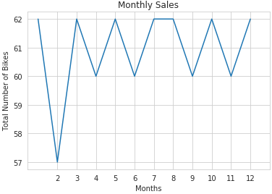
In [21]:
#Checking the distribution categorical Data using factorplot
sns.set_style("whitegrid")
sns.factorplot(data=df, x='dteday', kind= 'count', size=4,aspect=2)
sns.factorplot(data=df, x='yr', kind= 'count', size=4,aspect=2)
sns.factorplot(data=df, x='mnth', kind= 'count', size=4,aspect=2)
sns.factorplot(data=df, x='season', kind= 'count', size=4,aspect=2)
sns.factorplot(data=df, x='weathersit', kind= 'count', size=4,aspect=2)
sns.factorplot(data=df, x='workingday', kind= 'count', size=4,aspect=2)

Out[21]:
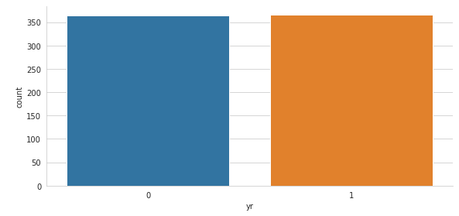

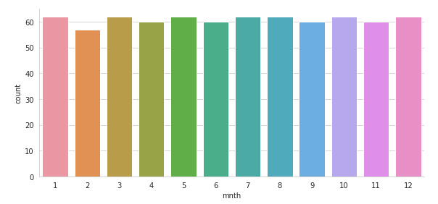
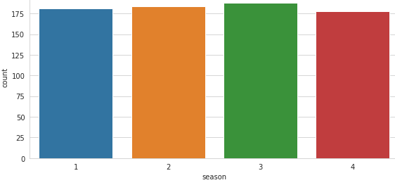

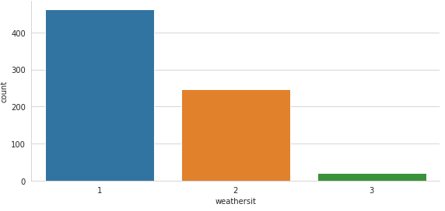

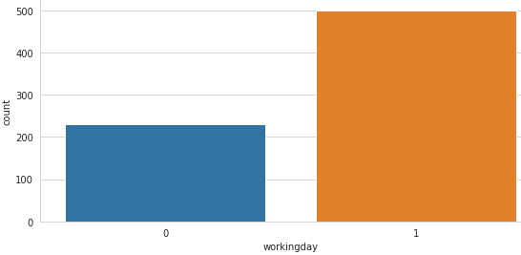

In [22]:#Scatter plot for temprature against bike rentals
sns.scatterplot(data=df,x='actual_temp', y='cnt')
Out[22]:
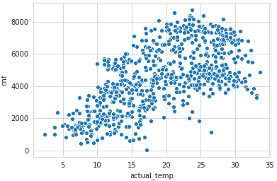

In [23]:#Scatter plot for humidity against bike rentals
sns.scatterplot(data=df,x='actual_hum',y='cnt')
Out[23]:
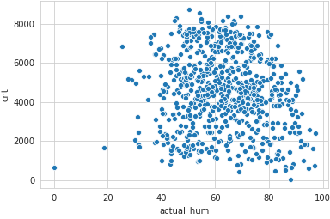

In [24]:#Scatter plot for atemp(feeled_temparature) against bike rentals
sns.scatterplot(data=df,x='actual_atemp',y='cnt')
Out[24]:
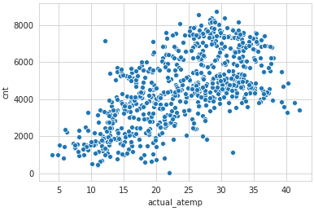
In [25]:
#Scatter plot for windspeed against bike rentals
sns.scatterplot(data=df,x='actual_windspeed',y='cnt')
Out[25]:
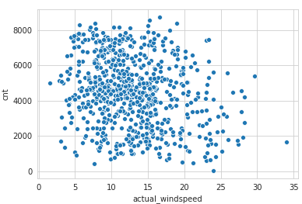

Outlier Analysis
In [26]: df.columns
Out[26]: Index(['dteday', 'season', 'yr', 'mnth', 'holiday', 'weekday', 'workingday', 'weathersit', 'temp', 'atemp', 'hum', 'windspeed', 'casual', 'registered', 'cnt', 'actual_temp', 'actual_atemp', 'actual_windspeed', 'actual_hum'],dtype='object')

In [27]: #Checking Outliers in data using boxplot
sns.boxplot(data=df[['actual_temp','actual_atemp','actual_windspeed','actual_hum']])
fig=plt.gcf()
fig.set_size_inches(8,8)
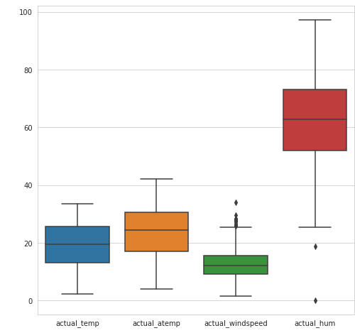
In [28]: sns.boxplot(data=df[['season','mnth','holiday','weekday']])
fig=plt.gcf()
fig.set_size_inches(8,8)
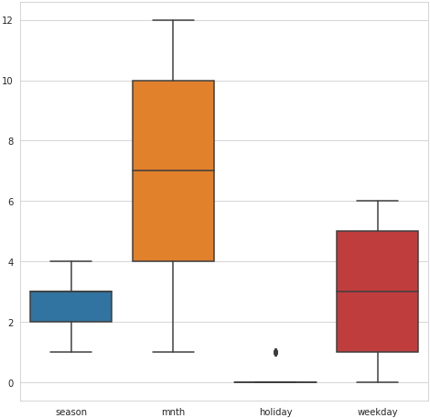

In [29]:
sns.boxplot(data=df[['workingday','weathersit','casual','registered']])
fig=plt.gcf()
fig.set_size_inches(8,8)
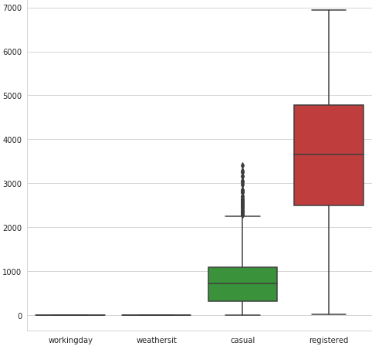

In [30]: #Variables that are used to remove outliers
#Not considering casual because this is not predictor variable
#Not considering holiday because workingday variable includes holiday, so there is no usefulness of considering holiday variables.
out_names = ['actual_windspeed', 'actual_hum']

In [31]:#Detecting and Removing Outliers
for i in out_names :
print (i)
q75,q25 = np.percentile(df.loc[:,i],[75,25])
iqr = q75-q25

min = q25 - (iqr*1.5)
max = q75 + (iqr*1.5)
print (min)
print (max)

df = df.drop(df[df.loc[:,i] < min].index)
df = df.drop(df[df.loc[:,i] > max].index)

Feature Selection
In [32]: #Checking Outliers in data after outliers removal using boxplot
sns.boxplot(data=df[['actual_temp','actual_atemp','actual_windspeed','actual_hum']])
fig=plt.gcf()
fig.set_size_inches(8,8)
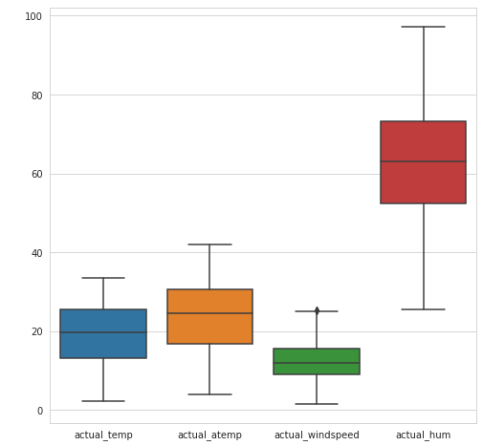

In [33]: df.head()
Out[33]:
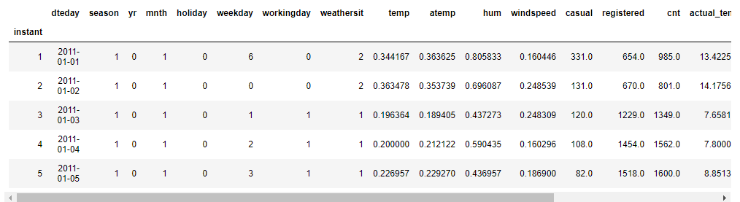

In [34]: continuous_variables = [ 'temp','atemp', 'hum', 'windspeed', 'casual','registered', 'cnt', 'actual_temp', 'actual_atemp', 'actual_windspeed', 'actual_hum']

In [35]: #Feature selection on the basis of Correlation, multcollinearity and variable importance
#cnames = ["actual_temp","actual_atemp","actual_hum","acttual_windspeed"]
#cnames = ["temp","atemp","hum","windspeed"]

df_cor = df.loc[:,continuous_variables]
f, ax = plt.subplots(figsize=(10,10))

#Generate correlation matrix
cor_mat = df_cor.corr()

#Plot using seaborn library
sns.heatmap(cor_mat, mask=np.zeros_like(cor_mat, dtype=np.bool), cmap=sns.diverging_palette(220, 10, as_cmap=True),square=True, ax=ax)
plt.plot()
Out[35]:
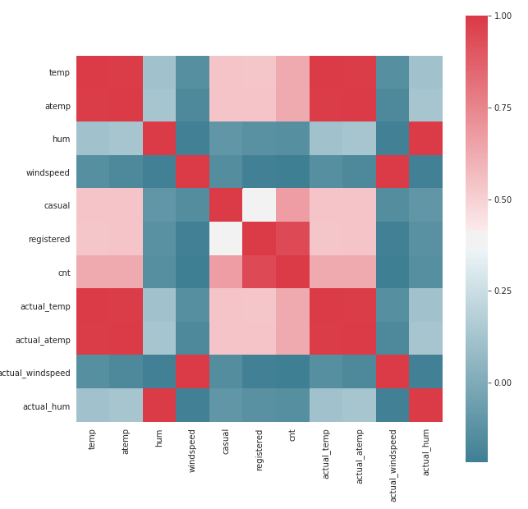
Hypothesis Testing
Null Hypothesis
Two variables are independent

Alternate Hypothesis
Two variables are not independant**

If p-value is less than 0.05 then reject null hypothesis, that means two variables are dependant but in our case most of the p-value are greater than 0.05,hence we need to accept that we failed to reject null hypothesis.

In [36]:
cat_columns = ['season', 'yr', 'mnth', 'holiday', 'weekday','workingday', 'weathersit']
# making every combination from cat_columns
factors_paired = [(i,j) for i in cat_columns for j in cat_columns]
factors_paired
p_values = []
from scipy.stats import chi2_contingency
for factor in factors_paired:
if factor[0] != factor[1]:
chi2, p, dof, ex = chi2_contingency(pd.crosstab(df[factor[0]], df[factor[1]]))
p_values.append(p.round(3))
else:
p_values.append('-')
p_values = np.array(p_values).reshape((7,7))
p_values = pd.DataFrame(p_values, index=cat_columns, columns=cat_columns)
print(p_values)
season yr mnth holiday weekday workingday weathersit
season - 0.999 0.0 0.641 1.0 0.946 0.013
yr 0.999 - 1.0 0.995 1.0 0.956 0.183
mnth 0.0 1.0 - 0.571 1.0 0.993 0.01
holiday 0.641 0.995 0.571 - 0.0 0.0 0.599
weekday 1.0 1.0 1.0 0.0 - 0.0 0.249
workingday 0.946 0.956 0.993 0.0 0.0 - 0.294
weathersit 0.013 0.183 0.01 0.599 0.249 0.294 -

In [37]:
# checking vif of numerical column without dropping multicollinear column
from statsmodels.stats.outliers_influence import variance_inflation_factor as vf
from statsmodels.tools.tools import add_constant
continuous = add_constant(df[['temp', 'atemp', 'hum', 'windspeed']])
vif = pd.Series([vf(continuous.values, i) for i in range(continuous.shape[1])], index = continuous.columns)
print(vif.round(1))

# Checking VIF values of numeric columns after dropping column atemp
from statsmodels.stats.outliers_influence import variance_inflation_factor as vf
from statsmodels.tools.tools import add_constant
continuous = add_constant(df[['temp', 'hum', 'windspeed']])
vif = pd.Series([vf(continuous.values, i) for i in range(continuous.shape[1])], index = continuous.columns)
vif.round(1)
const 46.4
temp 63.3
atemp 63.9
hum 1.1
windspeed 1.1
dtype: float64

Out[37]:
const 41.6
temp 1.0
hum 1.1
windspeed 1.1
dtype: float64

In [38]:
#Removing variables atemp beacuse it is highly correlated with temp,
#Removing weekday, holiday because they don't contribute much in predicting target variable
#Removing Causal and registered because that is what we need to predict.
df = df.drop(columns=['holiday','dteday','atemp','casual','registered','actual_temp','actual_atemp','actual_windspeed', 'actual_hum'])

In [39]: df.head(10)
Out[39]:
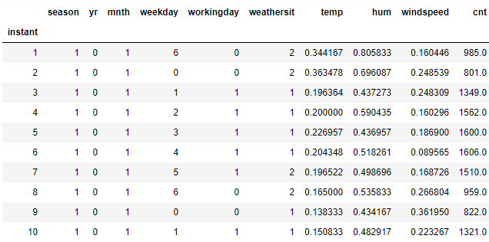

In [40]:
df.columns
Out[40]:
Index(['season', 'yr', 'mnth', 'weekday', 'workingday', 'weathersit', 'temp',
'hum', 'windspeed', 'cnt'] dtype='object')

In [41]: df2 = df.copy()

In [42]: categorical_var = ['season', 'yr', 'mnth', 'weekday', 'workingday', 'weathersit']

In [43]: df2.columns
Out[43]:
Index(['season', 'yr', 'mnth', 'weekday', 'workingday', 'weathersit', 'temp', 'hum', 'windspeed', 'cnt'], dtype='object')

In [44]: #Dummy Variable creation for categorical variables
df2 = pd.get_dummies(data = df2,columns=categorical_var)
In [45]:
df2.columns
Out[45]:
Index(['temp', 'hum', 'windspeed', 'cnt', 'season_1', 'season_2', 'season_3',
'season_4', 'yr_0', 'yr_1', 'mnth_1', 'mnth_2', 'mnth_3', 'mnth_4',
'mnth_5', 'mnth_6', 'mnth_7', 'mnth_8', 'mnth_9', 'mnth_10','mnth_11',
'mnth_12', 'weekday_0', 'weekday_1', 'weekday_2', 'weekday_3',
'weekday_4', 'weekday_5', 'weekday_6', 'workingday_0', 'workingday_1',
'weathersit_1', 'weathersit_2', 'weathersit_3'], dtype='object')

In [46]:
df2['count'] = df2['cnt']
df2 = df2.drop('cnt',axis=1)
df2.columns
Out[46]:
Index(['temp', 'hum', 'windspeed', 'season_1', 'season_2', 'season_3',
'season_4', 'yr_0', 'yr_1', 'mnth_1', 'mnth_2', 'mnth_3', 'mnth_4',
'mnth_5', 'mnth_6', 'mnth_7', 'mnth_8', 'mnth_9', 'mnth_10','mnth_11',
'mnth_12', 'weekday_0', 'weekday_1', 'weekday_2', 'weekday_3',
'weekday_4', 'weekday_5', 'weekday_6', 'workingday_0', 'workingday_1',
'weathersit_1', 'weathersit_2', 'weathersit_3', 'count' dtype='object')

In [47]:
df_plt_tree = df2.drop('count', axis=1)
df2.shape
Out[47]: (717, 34)

Model Development
In [48]: #Import Libraries for decision tree
from sklearn.tree import DecisionTreeRegressor
from sklearn.metrics import accuracy_score,r2_score,mean_squared_error
from sklearn.model_selection import train_test_split
from sklearn import tree

In [49]:
#Splitting data into train and test data
train,test = train_test_split(df2,test_size = 0.2, random_state = 123)

In [50]:
#Function for Performing all the tasks such as Error metrix rmse,mape,r-squared,accuracy,predictions
def evaluate(model, test_features, test_actual):
predictions = model.predict(test_features)
#Creating new data frame for comparing actual and predicted values
df_Dt = pd.DataFrame({'actual':test_actual,'predicted':predictions})
errors = abs(predictions - test_actual)
mape = 100 * np.mean(errors / test_actual)
Accuracy = 100 - mape
rmse = np.sqrt(mean_squared_error(test_actual,predictions))
rsquared = r2_score(test_actual, predictions)
print('<---Model Performance--->')
print('R-Squared Value = {:0.2f}'.format(rsquared))
print('RMSE = {:0.2f}'.format(rmse))
print('MAPE = {:0.2f}'.format(mape))
print('Accuracy = {:0.2f}%.'.format(accuracy))
return

Decision Tree
In [51]:
#Decision Tree model development
#Training the model with train data
model = DecisionTreeRegressor(random_state = 123).fit(train.iloc[:,0:33],train.iloc[:,33])

#Function for predictions, Error metrix rmse,mape,r-squared,accuracy
evaluate(model, test.iloc[:,0:33], test.iloc[:,33])

<---Model Performance--->
R-Squared Value = 0.73
RMSE = 962.42
MAPE = 17.75
Accuracy = 82.25%.

Linear Regression
In [52]:
#import libraries for Linear regression
from sklearn.linear_model import LinearRegression

#Create model Linear Regression using LinearRegression
model = LinearRegression().fit(train.iloc[:,0:33],train.iloc[:,33])

#Function for predictions, Error metrix rmse,mape,r-squared,accuracy
evaluate(model, test.iloc[:,0:33], test.iloc[:,33])
<---Model Performance--->
R-Squared Value = 0.78
RMSE = 872.05
MAPE = 17.18
Accuracy = 82.82%.

Random forest
In [53]:
#Import the libraries for Random Forest
from sklearn.ensemble import RandomForestRegressor
#Train the model
Rf_model = RandomForestRegressor(n_estimators=500,random_state=123).fit(train.iloc[:,0:33], train.iloc[:,33])

#Function for predictions, Error metrix rmse,mape,r-squared,accuracy
evaluate(Rf_model, test.iloc[:,0:33], test.iloc[:,33])
<---Model Performance--->
R-Squared Value = 0.87
RMSE = 669.23
MAPE = 12.89
Accuracy = 87.11%.

R-Code:
#Remove all objects stored
rm(list = ls())
#Loading Libraries
libraries = c("plyr","dplyr", "ggplot2","rpart","dplyr","DMwR","randomForest",
"usdm","corrgram","DataCombine")
lapply(X = libraries, require, character.only = TRUE)
rm(libraries)
library(dummies)
library(caret)
library(rpart.plot)
#Loading the data
df = read.csv("day.csv",header=T)
#first few rows of data
head(df)
#str names of data
str(df)

################# Exploratory Data Analysis ##############
df$dteday = as.Date(df$dteday)
df$season = as.factor(df$season)
df$yr = as.factor(df$yr)
df$mnth = as.factor(df$mnth)
df$holiday = as.factor(df$holiday)
df$weekday = as.factor(df$weekday)
df$workingday = as.factor(df$workingday)
df$weathersit = as.factor(df$weathersit)

################## Feature Engineering #####################
#Creating new variables
df$actual_temp = df$temp * 39
df$actual_atemp = df$atemp * 50
df$actual_windspeed = df$windspeed * 67
df$actual_hum = df$hum * 100

df$actual_season = factor(x = df$season, levels = c(1,2,3,4), labels = c("Spring","Summer","Fall","Winter"))
df$actual_year = factor(x = df$yr, levels = c(0,1), labels = c("2011","2012"))
df$actual_workingday = factor(x = df$workingday, levels = c(0,1), labels = c("Holiday", "Working day"))
df$actual_weathersit = factor(x = df$weathersit, levels = c(1,2,3,4),
labels = c("Clear","Cloudy/Mist","Rain/Snow/Fog","Heavy Rain/Snow/Fog"))

################# Missing value analysis ##############
missing_val = sapply(df,function(x){sum(is.null(df))})
missing_val

#There is no missing values so will move forward to data distribution
########## Exploring data distribution by graphs ###############
#checking data distribution of categorical variables using bar graphs
bar_season = ggplot(data = df,aes(x = actual_season)) +
geom_bar(fill = 'blue')+ggtitle("Count of Season")
bar_season

bar_weather = ggplot(data = df,aes(x = actual_weathersit)) +
geom_bar(fill = 'blue')+ggtitle("Count of Weatherlist")
bar_weather
bar_workingday = ggplot(data = df,aes(x = actual_workingday)) +
geom_bar(fill = 'blue')+ggtitle("Count of Workingday")
bar_workingday

gridExtra::grid.arrange(bar_season,bar_weather,bar_workingday,ncol=2)

#Checking data distribution numerical variables using histograms
hist_temp = ggplot(data = df, aes(x =actual_temp)) + ggtitle("Distribution of Temperature") + geom_histogram(bins = 25,fill='blue')
hist_atemp = ggplot(data = df, aes(x =actual_atemp)) + ggtitle("Distribution of feeled Temprature") + geom_histogram(bins = 25,fill='blue')
hist_windspeed = ggplot(data = df, aes(x =actual_windspeed)) + ggtitle("Distribution of Windspeed") + geom_histogram(bins = 25,fill='blue')
hist_hum = ggplot(data = df, aes(x =actual_hum)) + ggtitle("Distribution of Humidity") + geom_histogram(bins = 25,fill='blue')

gridExtra::grid.arrange(hist_temp,hist_atemp,hist_windspeed,hist_hum,ncol=2)

########### Outlier Analysis ################
continous_var = c("actual_temp","actual_atemp","actual_windspeed","actual_hum")
for (i in 1:length(continous_var))
{
assign(paste0("gn",i), ggplot(aes_string(y = continous_var[i]), data = df)+
stat_boxplot(geom = "errorbar", width = 0.5) +
geom_boxplot(outlier.colour="red", fill = "grey" ,outlier.shape=18,
outlier.size=1, notch=FALSE) +
theme(legend.position="bottom")+
labs(y=continous_var[i])+
ggtitle(paste("Box plot for", continous_var[i])))
}
gridExtra::grid.arrange(gn1,gn3,gn2,gn4,ncol=2)

#Found that outliers in actual_windspeed and actual_hum
#Removing outliers in Windspeed
val = df[,19][df[,19] %in% boxplot.stats(df[,19])$out]
df = df[which(!df[,19] %in% val),]

#Removing outliers in humidity
val = df[,20][df[,20] %in% boxplot.stats(df[,20])$out]
df = df[which(!df[,20] %in% val),]
colnames(df)
######################## Feature Selection ########################
#Checking multicollinearity using VIF
df_vif = df[,c('temp','atemp','windspeed','hum')]
vifcor(df_vif1)

#Checking Collinearity by using Correlation graph
corrgram(df, order = FALSE,lower.panel = panel.shade,upper.panel = panel.pie,
text.panel = panel.txt, main="Correlation Graph")
#From above 2 Correlation analysis observed 'atemp' variable has multicollinearity problem
#Removing unwanted variables
df = subset(df,select = -c(holiday,instant,dteday,atemp,casual,registered,actual_temp,actual_atemp,actual_windspeed,
actual_hum,actual_season,actual_year,actual_workingday,actual_weathersit))
#Taking copy of data
df2 = df
#df = df2
colnames(df)
#Creating dummy variables for categorical variables to trick the Regression models
catagorical_var = c('season','yr','mnth','weekday','workingday','weathersit')
df = dummy.data.frame(df, catagorical_var)
colnames(df)
rmExcept(keepers = 'df')
####################### Model Development ##########################
#Splitting data into train and test data
train_index = sample(1:nrow(df), 0.8*nrow(df))
train = df[train_index,]
test = df[-train_index,]
#-------------------Decision Tree----------------------#
#training the data with rpart
dt_model = rpart(cnt ~ ., data = train,method = "anova")
rpart.plot(dt_model)
#Predicting test data
dt_predictions = predict(dt_model,test[,-34])
#Create dataframe for actual and predicted values
df_pred = data.frame("actual"=test[,34], "pred"=dt_predictions)
head(df_pred)
summary(dt_model)
#Calculate RMSE and other error metrics
regr.eval(trues = test[,34], preds = dt_predictions, stats = c("mae","mse","rmse","mape"))
#Calculate R-Squared
print(postResample(pred = dt_predictions, obs = test[,34]))
# RMSE Rsquared MAE
#961.0064188 0.7676469 736.2084616
#--------------------Linear Regression---------------------#
#Train the data using linear regression
lr_model = lm(formula = cnt~., data = train)
#Check the summary of the model
summary(lr_model)
#Predict the test cases
lr_predictions = predict(lr_model, test[,-34])
#Create dataframe for actual and predicted values
df_lin = cbind(df_pred,lr_predictions)
head(df_lin)
#Calculate RMSE and other error metrics
regr.eval(trues = test[,34], preds = lr_predictions, stats = c("mae","mse","rmse","mape"))
#Calculate R-Squared
print(postResample(pred = lr_predictions, obs = test[,34]))
# RMSE Rsquared MAE
#847.8232089 0.8209717 629.3466018
#--------------------------Random Forest-------------------#
#Train the data using random forest
rf_model = randomForest(cnt~., data = train, ntree = 500)
#Predict the test cases
rf_predictions = predict(rf_model, test[,-34])
#Create dataframe for actual and predicted values
df_lin = cbind(df_lin,rf_predictions)
head(df_lin)
#Calculate RMSE and other error metrics
regr.eval(trues = test[,34], preds = rf_predictions, stats = c("mae","mse","rmse","mape"))
MAPE(test[,34], rf_predictions)
#Calculate R-Squared
print(postResample(pred = rf_predictions, obs = test[,34]))
# RMSE Rsquared MAE
#693.8210337 0.8804323 512.0623566

